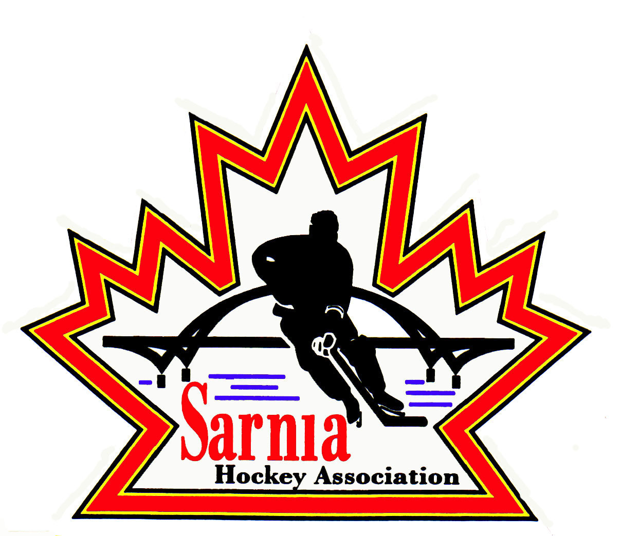

Sarnia Hockey Association

Minutes | Date: JuLY 8, 2025 | time 7:00 pm

Meeting called by | Paul Walsh, President
Type of meeting | Regular
Secretary | Kelly Lane, Recording Secretary

Welcome | Paul Walsh, President, and meeting Chair welcomed everyone and called the meeting to order at 7:08 pm.

ATTENDANCE | Tom Babcock, Andrew Beasley, Jerry Bernardo, Emily Brown, Jeff Dale, Ian Dunn, Pat Forbes, Terry Gray, Ryan Gruntz, Dan Hunt, Kelly Lane, Linda Lauzon, John Mellor, Kyle Mellor, Nick Mroczek, John Ritchie, Carrie Ritchie, Wayne Scarrow, Jason Teather, Barb Walsh, Paul Walsh  Regrets: Heather Amaral, Jacquie Beasley, Alister Brown, Paul Douglass, Chuck Ewart, Jeff Fogal, Bonny Marcy, Ted Pendle, David Penner

ACCEPTANCE OF MINUTES | MOTION #250708-001  “That the Minutes from June 18, 2025, be accepted as presented.” (J. Ritchie/K. Mellor)  Carried

TREASURER’S REPORT | - Financial Statement to the end of June 2025 was sent out to the SHA Board via email.  - Benevity money is starting to be received for the upcoming season. We will track and release the funds when team accounts are set up.  - Registration revenue is coming in and payment plans will take us through the summer.  - Rep Team loans up to maximum of $8,000 are provided to teams to cover the upfront cost of tournament registrations. $53,000 has gone out so far. These loans will be repaid in full by November 1.  - $13,000 has been received so far for Silver Stick tournament fees.  MOTION #250708-002  “That the financial Report be accepted as presented.” (E. Brown/J. Mellor)  Carried  - Still some teams that are slow in getting rep team bank accounts set up. Loans will go out when they are set up.  - Cousi Golf Tournament is coming up on July 26. They are still short teams.

BILLS TO BE PAID | MOTION #250708-003  “That the bills be paid as presented.” (E. Brown/C. Ritchie)  Carried
  Recipient | Expense | AMOUNT
  Sports Headz  Emily Brown  Dan Hunt  Paul Walsh  Linda Lauzon | Team and tournament pages  Quickbooks monthly fee (x 3 months), PO Box Annual Renewal, City of Sarnia desk payment  Police check, Alliance AGM travel and honorarium as per policy 1.04.06 (b)  Alliance AGM accommodations, meals and registration for multiple attendees  Ice Scheduler honorarium (June/July) | $ 2,754.93  $ 618.92  $ 436.70  $ 1,210.38  $ 660.00

PREVIOUS MEETING FOLLOW UP | POLICY APPROVAL:  - 4.16.05 a and b reviewed by PRAC. Final policy 4.16 House League Select was attached to the meeting Agenda. The Motion was tabled at the last meeting.  MOTION #250708-004  “That Policy 4.16 House League Select Hockey be approved.” (Douglass/K. Mellor)  Carried  - Select jerseys and socks will be added to Rec League order so that we get preferred pricing.

RECREATIONAL  REGISTRAR | REGISTRATION NUMBERS:  FOUNDATIONS SPOTS REMAINING:  U6 - Foundations - 70 registered - 25 spots remaining  U7 - Foundations - 19 registered - 1 spots remaining  U8 - Foundations - 3 registered - 7 spots remaining  U9 - Foundations - 3 registered - 4 spots remaining  U10 - Foundations - 3 registered - 2 spots remaining  U11 - Foundations - 1 registered - 2 spots remaining  Total Players registered Rep/MD/Foundations/Rec. - 773 participants  - We will do a FB boost as of July 18.  - We will post on SHA website advising that the late fee starts as of August 2.  - Registrar will send out information on those willing to volunteer to the Rec Directors.  - OPP indicates that there is a three month wait for VSC’s currently.  - U9 – discussion about how many players per team. Budgeted 8 teams of 19. We have enough ice for 10 teams but may have to order additional jerseys.  - Could look at doing team parity in U9. Rosters lock on January 10 so need to be cognizant of that.
  DIVISION | JULY 2, 2024 | JULY 8, 2025 | REP 2025
  Foundations | 79 | 99 | U8 MD 26
  U6/U7 | 72 | 78 41 remaining | U9 MD 29
  U8/U9 | 119 | 86 58 remaining | U10-U16 AA 118
  U11 | 106 | 58 78 remaining | U10-U16 BB 118
  U13 | 108 | 49 87 remaining | U18 AA 21
  U15 | 95 | 39 69 remaining | U18 BB 12
  U16-U18 | 49 | 40 80 remaining
  U21 | 7 |  | TOTAL REP and MD/REP
   |  |  | (TRYOUTS)
   | TOTAL 658 | TOTAL 449 | 324

VICE-PRESIDENT REPRESENTATIVE TEAMS | REP COUNCIL MEETINGS:  - Two meetings occurred over the last few weeks. Ice Scheduler and SHA President attended the meetings. A number of items were discussed:  OHF BULLETIN -SPRING/SUMMER PROGRAMMING:  - OHF Bulletin was released on Spring and Summer Program Sanctioning that sets framework for what Minor Hockey Associations can do following spring tryouts with key dates identified.  - From the end of spring evaluation, teams can focus on skill development up until June 30.  - From July 1 to Aug 10, no sanctioned programming is permitted for insurance coverage.  - There were some teams that wanted to do fundraising, but the direction from Alliance is teams cannot do it. Fundraising can occur as a private individual, but not as a team of Sarnia Hockey.  - If rent ice, teams would have to request additional insurance.  - From Aug 11-29, non-team-based skill development is allowed through HCR.  - From Aug 22-29, team building is permitted but no exhibition games are permitted.  - Associations must have approved roster.  - From August 30-Sept 1, no sanctioned programming is allowed.  - Sept 2 is the beginning of development phase for U8-U18. Fall tryouts can start. Prep skates can be run during the first week.  - AAA U18 tryouts will start and then SHA will do U18 AA tryouts when those are complete. We like to wait until Junior Camps are complete.  - This information has been sent out to the Rep Directors but can also go out on SHA web as a news item.  SPORTS PAY:  - For 2026/27 season, Hockey Canada will have a single pay provider, and it is Sports Pay. SHA has used Sports Pay for a few years.  CONCUSSION PROTOCOL MANAGEMENT:  - Question to Associations regarding who is using 3rd party for collection of data for Concussion Protocol Management. There doesn’t appear to be an interest and players/parents want to use their own physician or professionals in their local area. Each Association handles it themselves. Injury report goes to Alliance and then it is forwarded to Hockey Canada. SHA requires a doctor’s note for return to play. Form needs to be completed by Physician. Best to take form to be completed at the time of injury. We encourage trainers to have the forms with them so they can be given to injured player/family.  - Purpose is to protect players down the road, so it is important to have the injury documented at the time it occurred.  - SHA wants form completed and returned within 24-48 hours after the injury occurred. Hockey Canada deadline is 90 days after injury.  - It was suggested to also put forms in the Recreational mailbox for easy access to Rec coaches/trainers.  - The Injury form also get attached to player’s profile in HCR.  - If players’ own insurance doesn’t cover treatment, Hockey Canada will cover it.  AA SEEDED PLAYDOWNS:  - In previous years Associations were not allowed to schedule games during March Breach in U 10 and U11. This has been removed due to time crunch in getting games completed.  - For a few teams, their regular season was over at end of February and if they lost their first round their season was done. This year, if lose in the first round, teams go into the consolation round. The intent is to keep players on the ice for as long as we can before spring tryouts. It was a lot of down time for players before tryouts if they were out too early.  - They will play on until third week in March.  - Split dates were decided and how split would occur. There were a lot of discussions.  - In BB – split dates were decided. In U18 – option to play east west instead of playing everyone. East/west option was voted down.  - All the dates are set. Game scheduling will start at the end of July.

ICE DIRECTOR | - Calendars will start to be populated. Blackout dates were populated.  - Sting games entered as practice ice may be impacted.  - 11 rep teams have provided info on tournaments. U10B, U12B, U13B, and U18 A need to send in their tournament information including sanction number. Vice President Admin will follow up.  - Reminder to rep teams that they must adhere to the tournament policy. Teams can only have 4 black out weekends.  - Ice Scheduler is asking teams to not have back-to-back tournaments. It could lead to teams having weeknight games out of town.  - If coaches want to do double headers or stay overnight and do two games out of town let Ice Scheduler know as soon as possible.  - Rep Vice President will advise coaches of this.

SELECT DIRECTOR | - Coach applications have closed, and 14 applications were received.  MOTION #250708-005  “That the Select Team Coach Selection Committee to consist of Select Director, Skills Director, Michael Haley and Shawn Antosiak.” (J. Ritchie/Scarrow)  Carried  Other SHA members will be U11 Rec Director, U13 Rec Director and BB Rep Director.

REC LEAGUE DIRECTOR | - Jason Teather will continue on as Foundations Director.  - Rec Directors meeting to occur after this meeting.

REC SPONSORSHIP DIRECTOR | - Just need sponsors for U9 Division. Will be following up tomorrow with one potential sponsor.  - If not, we will do a post on social media wanting sponsors.

SKILLS DIRECTOR | - Skills Director to request bids to local providers to do prep skates. Cost and skill level to be taken into consideration.  - Skills Director to work with Ice Scheduler to confirm the ice for prep skates.  - Also, Skills Director to discuss PD Day Skill Development including Goalie Development with SHA Treasurer regarding Cousi funding for these sessions.

NEW BUSINESS | - Congratulations to former SHA player Jack Nesbitt who was drafted by the Philadelphia Flyers in the first round. He was a member of SHA up to U10. He was also a referee with SHA and a volunteer at Silver Stick. This will be posted on SHA social media.  NEXT MEETING:  - Next meeting is Wednesday, July 23, 2025 at Clearwater Lower Hall.

adjournment | MOTION #250708-006  “That the meeting be adjourned.” /Hunt/C. Ritchie)  Carried

Paul Walsh Kelly Lane
President Secretary

